

Article Reading Report
Acne Detection & Skin Analyzer Using Classical Image Processing

Course name: Introduction to Computer Vision

Instructor: Anxhelo Shehu

Oresti Duka – Software Engineering
Project Repository - https://github.com/Oresti44/acne-detection-skin-analyzer

1.Abstract
This work presents a rule-based computer vision system for analyzing facial images and estimating acne severity. The system applies classical digital image processing techniques such as face detection, preprocessing, segmentation, and feature extraction. Acne-like regions are identified using redness and texture cues, and a severity score is computed to classify the condition into Mild, Moderate, or Severe. The system produces both numerical and visual outputs, demonstrating a structured and explainable approach to skin analysis without relying on machine learning.

Input Result
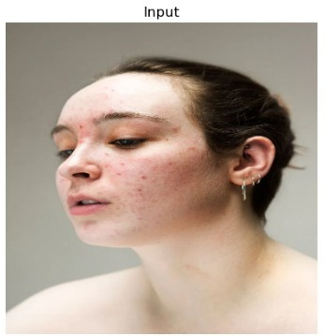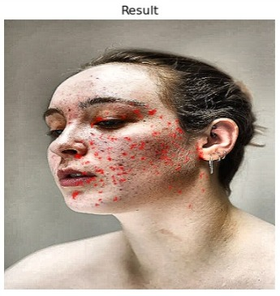

Rating
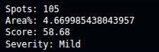

2. Introduction
Acne is a common dermatological condition that varies in severity and visual appearance. Automated analysis of facial images can support monitoring and basic assessment of acne severity.

This project focuses on building a system that analyzes facial images using classical image processing techniques rather than machine learning. The motivation behind this approach is to create an explainable and transparent system that clearly demonstrates each processing step.

Unlike modern AI-based solutions, this system relies on deterministic operations such as filtering, segmentation, and feature extraction. This makes it more suitable for an academic environment where understanding the process is more important than achieving perfect accuracy.
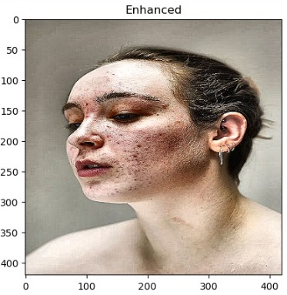
3. Problem Statement

Manual acne assessment is subjective and time-consuming. Most automated systems rely on complex machine learning models, which require large datasets and are difficult to interpret.
The goal of this project is to design a simple, explainable system that can:
- analyze facial images
- detect acne-like regions
- estimate severity using visible features
The system is not intended for medical diagnosis, but rather as an academic prototype demonstrating digital image processing techniques.
4. Objectives
Detect and isolate the face from an image
Preprocess the image for consistent analysis
Identify acne-like regions based on redness
Extract measurable features from the image
Compute a severity score
Classify acne severity into categories
Display visual and numerical results

5. Methods
5.1 Image Input and Validation
The system accepts an input image in standard formats (JPG/PNG). The image is checked for validity, size, and usability before further processing.

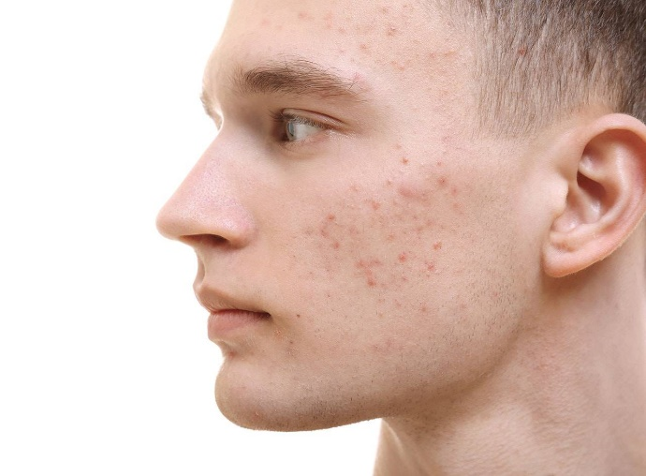

5.2 Face Detection and Cropping
The main face is detected using OpenCV-based methods. The detected region is cropped and used for further analysis. If multiple faces are present, the largest one is selected.
This step ensures that background elements do not interfere with the analysis.

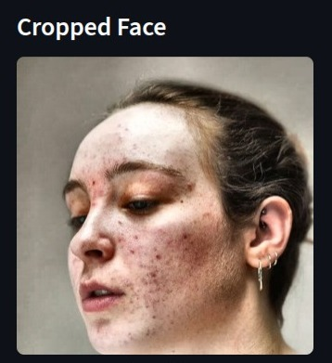

5.3 Preprocessing
The cropped face undergoes preprocessing to standardize the input:
a. resizing to fixed dimensions
b. Gaussian smoothing for noise reduction
c. color conversion (HSV and grayscale)
d. contrast normalization using CLAHE
These operations reduce variability due to lighting and image quality.

5.4 Region Focus and Skin Approximation
Non-relevant regions such as eyes, lips, and hair are partially excluded using masking techniques. This reduces false detections in non-skin areas.

5.5 Red Region Detection (Segmentation)
Acne-like regions are detected using color-based segmentation:
a. conversion to HSV color space
b. thresholding for red tones
c. morphological operations to refine the mask
d. connected component analysis to identify individual regions
Extracted features include:
a. red area percentage
b. number of regions
c. average region size
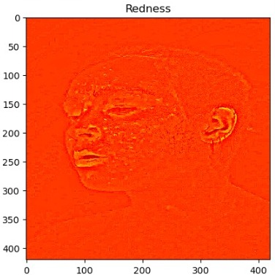
5.6 Texture Analysis
Skin texture is analyzed using:
a. Laplacian filtering
b. edge density
c. local variance
This helps identify irregular skin patterns.

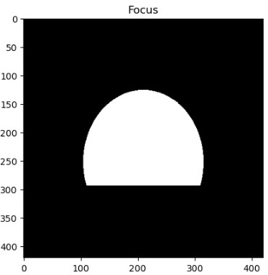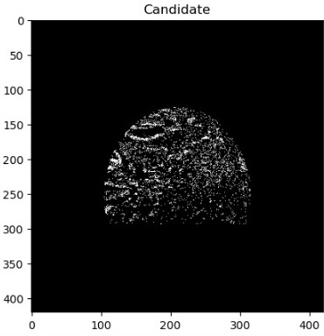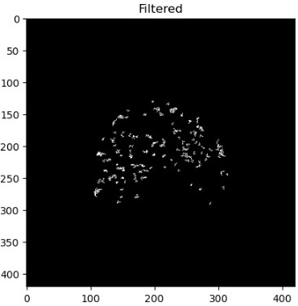

5.7 Feature Extraction and Scoring
The system converts visual information into numerical features:
a. red area percentage
b. spot count
c. average spot size
d. texture score

The severity score is computed using a rule-based formula based mainly on:
a. red area percentage
b. spot count

The result is mapped into:
-Clean
-Almost Clean
-Mild
-Moderate
-Severe

6. System Pipeline
-Upload image
-Validate input
-Detect face
-Crop face
-Preprocess image
-Detect red regions
-Analyze texture
-Extract features
-Compute severity
-Display results

7. Experiments
To evaluate the system, multiple facial images were tested under different conditions:
a. varying lighting conditions
b. different skin tones
c. front-facing and slightly angled faces
d. varying acne severity levels

8. Results
The system successfully performs:
a. face detection and cropping
b. segmentation of red/inflamed regions
c. extraction of relevant features
d. computation of severity score
e. classification into severity categories
The output includes:
a. visual representation (highlighted regions)
b. numerical results (score and label)
Example output:
Severity: Moderate
Score: 58/100



9. Discussion
The system performs well under controlled conditions but struggles with:
-poor lighting
-shadows
-facial hair
-red lips or makeup

The rule-based approach is explainable but not highly robust.

10. Limitations
-Not a medical diagnostic system
-Sensitive to lighting conditions
-Affected by skin tone variation
-False positives from lips or shadows
-No trained dataset
-Simplified scoring model

11. Future Work
-Improve skin masking
-Integrate machine learning models
-Use labeled datasets
-Add region-specific analysis
-Improve robustness
-Build mobile/web version

12. Conclusions
This project demonstrates how classical image processing techniques can be applied to estimate acne severity. While the system is not medically accurate, it provides a structured and interpretable approach suitable for academic purposes.
The project highlights both the strengths and limitations of rule-based methods and serves as a foundation for more advanced systems.

13. References
-OpenCV Documentation
-Digital Image Processing course materials
-Python Documentation
-Research articles on acne image analysis

